Name: Libiya Jose
Roll No:14
Batch:S2 MCA
Date:23/05/22

NETWORKING&SYSTEM ADMINISTRATION LAB

Experiment No: 24

Aim
Setting Up an Apache Container
Procedure:

Setting Up an Apache Container

One of the amazing things about the Docker ecosystem is that there are tens of standard containers that you can easily download and use.
In the following example, we will instantiate an Apache 2.4 container named tecmint-web, detached from the current terminal. We will use an image called httpd:2.4 from Docker Hub.
Our plan is to have requests made to our public IP address on port 8080 be redirected to port 80 on the container. Also, instead of serving content from the container itself, we will serve a simple web page from /home/user/website.
We do this by mapping /home/user/website/ on the /usr/local/apache2/htdocs/ on the container. Note that you will need to use sudo or login as root to proceed, and do not omit the forward slashes at the end of each directory.
$ sudo docker run -dit --name tecmint-web -p 8080:80 -v /home/user/website/:/usr/local/apache2/htdocs/ httpd:2.4

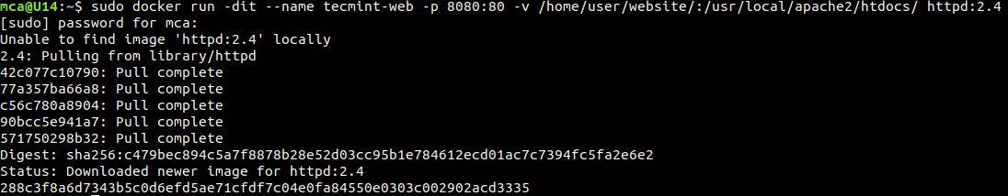

Pull Docker Apache Container
At this point, our Apache container should be up and running.
$ sudo docker ps

Check Apache Docker Container
Now let’s create a simple web page named docker.html inside the /home/user/website directory.
$ sudo gedit /home/user/website/docker.html

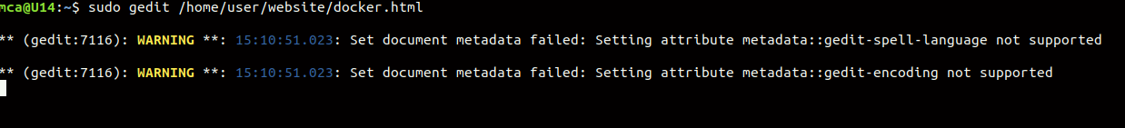
Add the following sample HTML content to the file.
<!DOCTYPE html>
<html lang="en">
<head>
<meta charset="UTF-8">
<title>Learn Docker at Tecmint.com</title>
</head>
<body>
<h1>Learn Docker With Us</h1>
</body>
</html>

Next, point your browser to c
(where Server-IP is your host’s public IP address). You should be presented with the page we created previously.
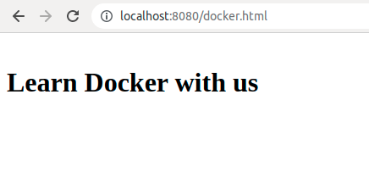

Check Apache Page
If you wish, you can now stop the container.

$ sudo docker stop tecmint-web

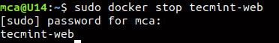

and remove it:
$ sudo docker rm tecmint-web

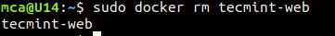

To finish cleaning up, you may want to delete the image that was used in the container (omit this step if you’re planning on creating other Apache 2.4 containers soon).

$ sudo docker image remove httpd:2.4

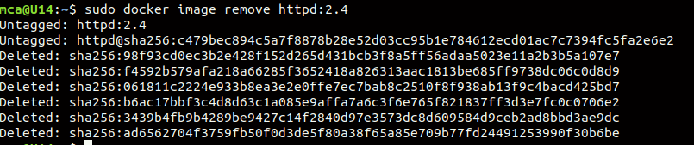

Note that in all the above steps we never had to install the webserver on our host.
$ sudo docker run -dit --name tecmint-web -p 8080:80 -v /home/user/website/:/usr/local/apache2/htdocs/ httpd:2.4
